Mandatory Pre-Posting on non-Part Purchase Order Line and Purchase Requisition Line – CRIM 0689

|  |  |  |  |  |
| --- | --- | --- | --- | --- |
| **Ver** | **Date** | **Author** | **Comments** | **Reviewed by** |
| 1 | 18/06/2021 | Tom Bell | CRIM 0689 | TBC |
|  |  |  |  |  |

Requirements 2

Prerequisites 2

Solution Overview 2

Solution Details 2

Security 3

Companies 3

Data Migration 3

Test Steps 3

Technical Implementation 3

Requirements

The system must make Pre-Postings Mandatory on No-Part Order Lines on both the Purchase Order and Purchase Requisition Screens.

Prerequisites

<Describe any pre-requisites that this development may rely upon, data configuration or other developments>

Solution Overview

Additional columns are required on the Procurement Basic Data screen, Purchase Groups tab containing check boxes.

Depending on what tick boxes are checked will determine what/if Pre-Posting data is mandatory for a particular Purchase Group.

When a user goes to change the status of the Purchase Order/Purchase Requisition (No Part Order) to Released, an event will take place to check that the ticked check boxes have Pre-Posting data for all of the Purchase Order/Purchase Requisition Lines. If there is no Pre-Posting data for any checked fields on the Procurement Basic Data screen, Purchase Groups tab screen then the Purchase Order/Purchase Requisition cannot be released.

**Logic Overview**

**Applicable to the following:**

Procurement> Order>Purchase Order screen.

OR

Procurement>Requisition>Purchase Requisition screen.

Where

* No Part Order Lines – any lines maintained in the No Part order Line tab.
* Part order lines – Any part which is a non-inventory purchase part, as per the flag on the purchase part screen where “SQL Column: INVENTORY_FLAG_DB” = FALSE

**Check the Procurement Basic data for Purchase Groups to see if any Mandatory field have been disabled for each.**

**event will take place that checks:**

* All Mandatory Pre-Posting field(s) have been populated. If there is required Pre-Posting data that has not been complete an error message will appear, detailing that Pre-Posting data is required in either one (or more) Purchase Order/ Purchase Requisition Lines.

Solution Details

# Event Pre-Requisites - Basic Data

In the Procurement Basic Data screen, Purchase Groups tab, the following columns are required, containing check boxes.

* **B – Proposition**
* **C – Project**
* **D – Site**
* **E – Cost Centre**
* **F – Contract**
* **G – Code G**
* **H - Inter Co**
* **I - Asset**
* **J – Currency**
* **MANDATORY PRE-POSTINGS FOR PURCHASE ORDER ENABLED**
* **MANDATORY PRE-POSTINGS FOR PURCHASE REQUISITION ENABLED**

The below screenshot shows where the Code Part columns and check boxes and columns should appear in red.

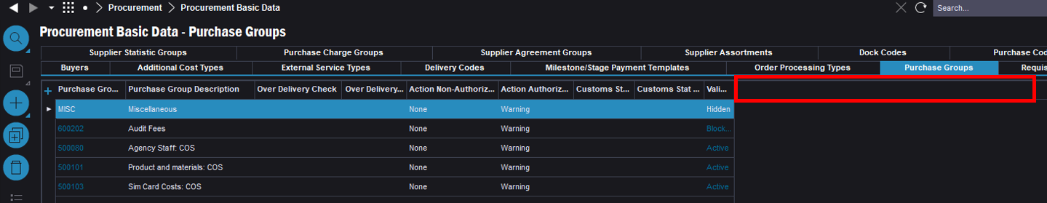

# Event Trigger

The event will be triggered by releasing a Purchase Order or a Purchase Requisition that has No-Part Order Lines or that has Part Order Lines with Non-Inventory Parts.

Data Locations

# Pre-Posting Data Location

1. The below screenshot shows the where the Pre-Posting data is required on the Purchase Order/Purchase Requisition screen.

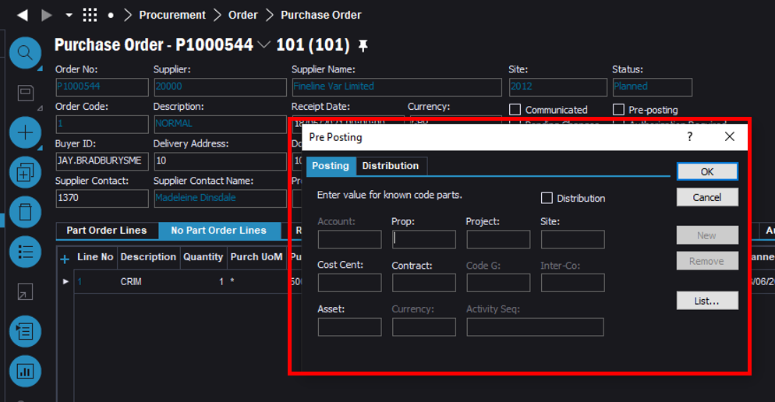

# Non-Inventory Part Checkbox Location

The below screenshot shows the Inventory Part checkbox. If this checkbox is FALSE then the Part is a “Non-Inventory Part” and will be subject to this CRIM event. Its Pre-Posting data will be checked for any mandatory Pre-Postings like all lines on the No Part Order tab.

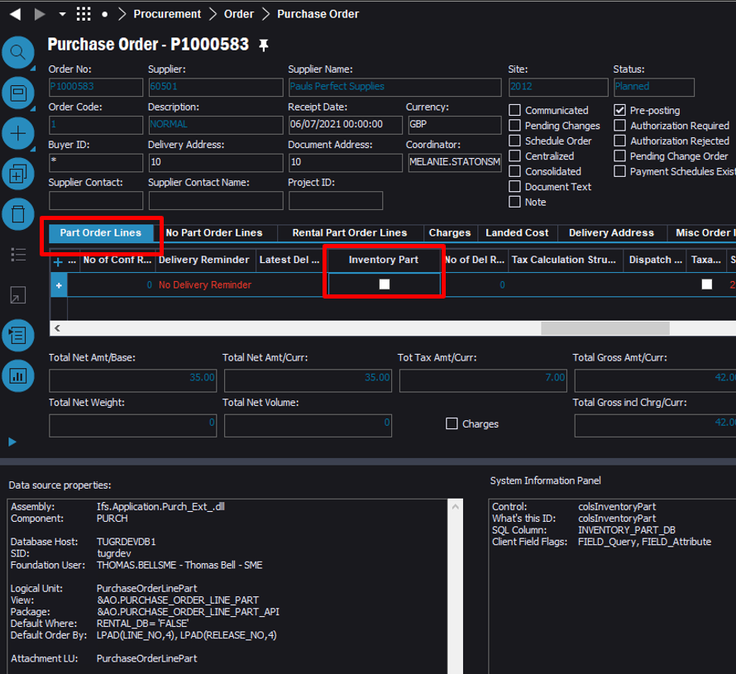

# Basic Data Location

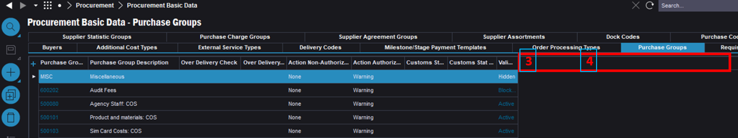

EVENT LOGIC

# Logic Breakdown

Below is a numbered screenshot of the Purchase Order screen. The below logic commentary will use these numbers as reference.

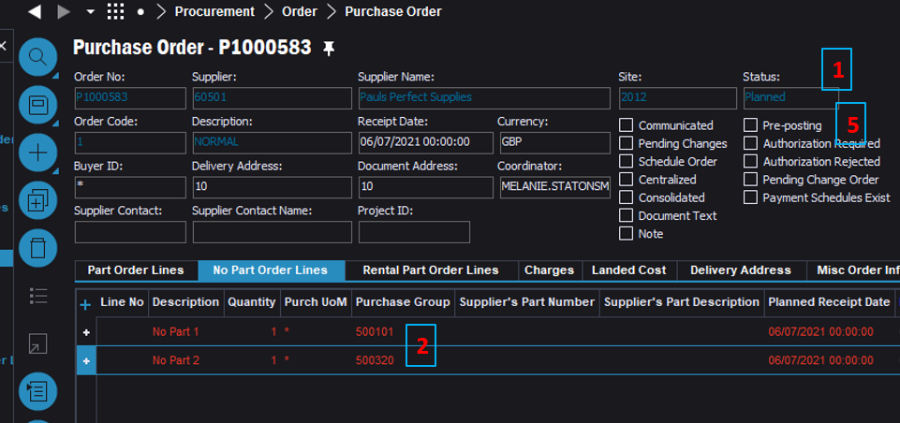

Below is a numbered screenshot of the Procurement Basic Data screen. The below logic commentary will use these numbers as reference.



# Logic Commentary

1. Trigger for the event will be the Purchase Order or Purchase Requisition being moved to status “Released” and there being No Part Order Lines. And/or Part Order Lines with the check box “Inventory Part = FALSE”.
2. The Lines that meet the above conditions, their Purchase Groups will be checked against the Procurement Basic Data screen.
3. Check column “MANDATORY PRE-POSTINGS FOR PURCHASE ORDERS” or “MANDATORY PRE-POSTINGS FOR PURCHASE REQUISITIONS” (columns tbc part of current CRIM). If true for one or more Purchase Groups the following takes place, if false end.
4. Check all Code Part columns of all Purchase Groups in the Order/Requisition, if one or more is TRUE then the following takes place.
5. On the Purchase Order/Requisition screen check the Pre-Posting data at Line level to ensure that the Mandatory Pre-Posting Code Part values (marked as true in the above step) for those Purchase Groups are present. If all Mandatory Pre-Posting Code Parts for all Purchase Groups for all Lines in the Order/Requisition contain values then Release PR/PO. If not then error.

# Remove Pre-Posting RMB from Header of Purchase Order and Purchase Requisition

Disable Header Level Pre-Postings. This CRIM event will only check the Purchase Req/Purchase Order Lines for Pre-Postings



Disable option highlighted in red for Pre-Postings at Header Level.

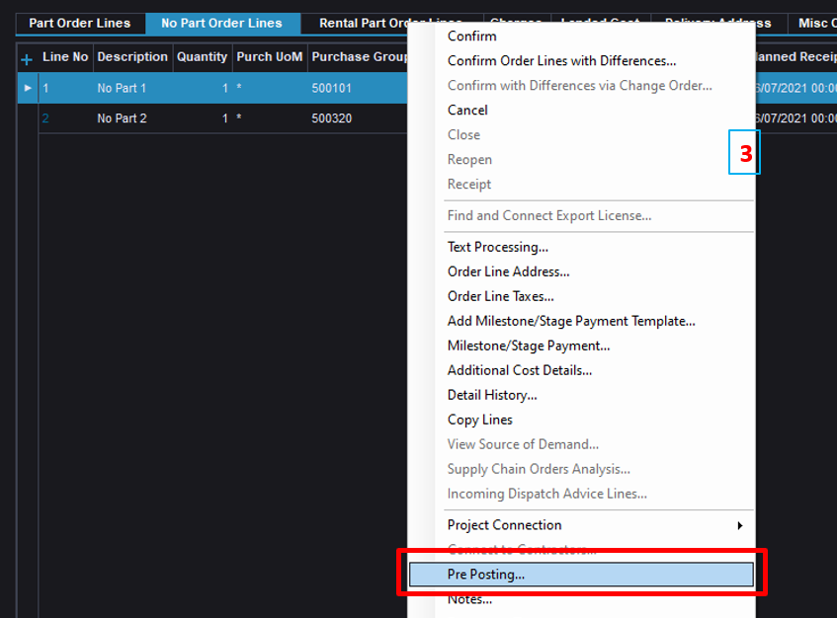

Error Handling

Require an Error Message to be displayed for every PR/PO Line that has errored.

An Error is defined as = a line does not have Mandatory Pre-Posting Code Part data entered.

Error messages need to be produced for every line that does not have the required mandatory Pre-Postings. This will help users know what Pre-Postings values to maintain.

One Error message must appear for every line that does not have the correct Code Parts entered.

***Error Message***

*“Insert tab name” for Line “Insert Line Number” requires mandatory Pre-Posting values for “ INSERT MANDAOTRY PRE-POSTING 1” , “MANDANTORY PRE-POSTING 2”, …. etc.”*

Technical.

Field Definitions.

<New Field/CLU Definition>

|  |  |  |  |  |  |  |
| --- | --- | --- | --- | --- | --- | --- |
| New DB Object Name | DB Object Item/Field Names | Item Description | Item Data Type | Item Syntax | Calculation Spec, if Derived | LOVs/Enums/Is Mandatory? |
|  |  |  |  |  |  |  |
|  |  |  |  |  |  |  |
|  |  |  |  |  |  |  |
|  |  |  |  |  |  |  |
|  |  |  |  |  |  |  |
|  |  |  |  |  |  |  |
|  |  |  |  |  |  |  |
|  |  |  |  |  |  |  |
|  |  |  |  |  |  |  |
|  |  |  |  |  |  |  |
|  |  |  |  |  |  |  |
|  |  |  |  |  |  |  |

Security

<Define security controls> (Who needs access to this and will it be restricted from any other users etc)

Companies

Applies to the following companies. All.

|  |  |
| --- | --- |
| **Company** | **Required (Y/N)** |
| 1201 | Y |
| TBC |  |
|  |  |

Data Migration

<Describe any data migration impacts this development may have – i.e additional data to be migrated>

Test Steps

<Steps that needs to be taken to test this change. Please provide expected results> Updated post solution.

|  |  |  |
| --- | --- | --- |
| **No** | **Script\Test Steps** | **Expected Result** |
| 1 |  |  |
| 2 |  |  |
| 3 |  |  |

Technical Implementation

<Completed by the technical developer - Technical solution, list packages, functions, Custom menus created etc >

**Delivery Notes**

**Application_Configuration_Package :** EA_FINANCE

**Two custom events :**

C_C0689_CHECK_PREPOST_PO

C_C0689_CHECK_PREPOST_PR

**Make sure two custom events are enabled.

**11 Custom fields attached to :** Procurement Basic Data->Purchase Group

**In order to visible the customer fields :**

1. Publish the ACP if some of the fields are not published.
2. Reload Configuration in window Procurement Basic Data->Purchase Group
3. Add the fields using column chooser

Please make sure to check following two custom fields to enable the validation for each object.

MANDATORY PRE-POSTINGS FOR PO

MANDATORY PRE-POSTINGS FOR PR